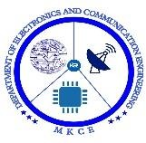

**BLUETOOTH BASED HOME AUTOMATION USING ARDUINO UNO**

#### A MINOR PROJECT- I REPORT

**Submitted by**

|  |  |
| --- | --- |
| **PRAVEEN S** | **927621BEC151** |
| **PAVITHRAN A V** | **927621BEC145** |
| **PRIYAKANTH K** | **927621BEC156** |
| **SABARI J** | **927621BEC168** |

### BACHELOR OF ENGINEERING

in

### DEPARTMENT OF ELECTRONICS AND COMMUNICATION ENGINEERING

**M.KUMARASAMY COLLEGE OF ENGINEERING**

(Autonomous)

### KARUR–639113

**DECEMBER 2022**

# M.KUMARASAMY COLLEGE OF ENGINEERING, KARUR

### BONAFIDE CERTIFICATE

Certified that this project report "BLUETOOTH BASED HOME AUTOMATION USING ARDUINO UNO " is the bonafide work of " PRAVEEN.S (927621BEC151), PAVITHRAN. A.V (927621BEC145), PRIYAKATH.K (927621BEC156), SABARI.J (927621BEC168)" who carried out the project work under my supervision in the academic year 2021-2022.

|  |  |
| --- | --- |
| **SIGNATURE** | **SIGNATURE** |
| Dr.S.PALANIVELRAJAN, M.E., Ph.D.,  **HEAD OF THE DEPARTMENT,** | Dr. D. JAYASEELAN, M.Tech., Ph.D.,  **SUPERVISOR** |
| Professor, | Assistant Professor, |
| Department of Electronics and | Department of Electronics and |
| Communication Engineering, | Communication Engineering, |
| M. Kumarasamy College of Engineering, | M. Kumarasamy College of Engineering, |
| Thalavapalayam, Karur-639113. | Thalavapalayam, Karur-639113. |

This Minor project-I report has been submitted for the **18ECP103L–MinorProject-I**

Review held at M. Kumarasamy College of Engineering, Karur on _________

**PROJECT COORDINATOR**

**Vision of the Institution**

To emerge as a leader among the top institutions in the field of technical education

#### Mission of the Institution

**M1:** Produces smart technocrats with empirical knowledge who can surmount the global challenges

**M2:** Create a divers, fully engaged, learner-centric campus environment to provide quality education to the students

**M3:** Maintain mutually beneficial partnerships with our alumni, industry, and Professional associations

#### Vision of the Department

To empower the Electronics and Communication Engineering students with emerging technologies, professionalism, innovative research, and social responsibility.

#### Mission of the Department

**M1:** Attain the academic excellence through innovative teaching learning process, research areas &laboratories and Consultancy projects.

**M2:** Inculcate the students in problem solving and lifelong learning ability.

**M3:** Provide entrepreneurial skills and leadership qualities.

**M4:** Render the technical knowledge and skills of faculty members.

#### Program Educational Objectives(PEOs):

**PEO1: Core Competence:** Graduates will have a successful career in academia or industry associated with Electronics and Communication Engineering.

**PEO2: Professionalism:** Graduates will provide feasible solutions for the challenging problems through comprehensive research and innovation in the allied areas of Electronics and Communication Engineering.

**PEO3: Lifelong Learning:** Graduates will contribute to the social needs through lifelong learning, practicing professional ethics and leadership quality.

**Program Outcomes (POs):**

**PO1: Engineering knowledge:** Apply the knowledge of mathematics, science, engineering fundamentals, and an engineering specialization to the solution of complex engineering problems.

**PO2: Problem analysis:** Identify, formulate, review research literature, and analyze complex engineering problem reaching substantiated conclusions using first principles of mathematics, natural sciences, and engineering sciences.

**PO3:Design/development of solutions:** Design solutions for complex engineering problems and design system components or processes that meet the specified needs with appropriate consideration for the public health and safety, and the cultural, societal, and environmental considerations.

**PO4: Conduct investigations of complex problems:** Use research-based knowledge and research methods including design of experiments, analysis and interpretation of data, and synthesis of the information to provide valid conclusions.

**PO5: Modern tool usage:** Create, select, and apply appropriate techniques, resources, and modern engineering and IT tools including prediction and modeling to complex engineering activities with an understanding of the limitations.

**PO 6: The engineer and society:** Apply reasoning informed by the contextual knowledge to assess societal, health, safety, legal and cultural issues, and the consequent responsibilities relevant to the professional engineering practice.

**PO7: Environment and sustainability:** Understand the impact of the professional engineering solutions in societal and environmental contexts, and demonstrate the knowledge of, and need for sustainable development.

**PO 8: Ethics:** Apply ethical principles and commit to professional ethics and responsibilities and norms of the engineering practice.

**PO 9: Individual and teamwork:** Function effectively as an individual, and as a member or leader in diverse teams, and in multidisciplinary settings.

**PO10: Communication:** Communicate effectively on complex engineering activities with the engineering community and with society at large, such as, being able to comprehend and write effective reports and design documentation, make effective presentations, and give and receive clear instructions.

**PO11: Project management and finance:** Demonstrate knowledge and understanding of the engineering and management principles and apply these to one’s own work, as a member and leader in a team, to manage projects and in multidisciplinary environments.

**PO 12: Life-long learning:** Recognize the need for and have the preparation and ability to engage in independent and life-long learning in the broadest context of technological change.

#### Program Specific Outcomes (PSOs):

**PSO1:** Applying knowledge in various areas, like Electronics, Communications, Signal processing, VLSI, Embedded systems etc., in the design and implementation of Engineering application.

**PSO2:** Able to solve complex problems in Electronics and Communication Engineering with analytical and managerial skills either independently or in team using latest hardware and software tools to fulfill the industrial expectations

**Program Specific Outcomes**

**PSO1:** Applying knowledge in various areas, like Electronics, Communications, Signal processing, VLSI, Embedded systems etc., in the design and implementation of Engineering application.

**PSO2:** Able to solve complex problems in Electronics and Communication Engineering with analytical and managerial skills either independently or in team using latest hardware and software tools to fulfill the industrial expectations.

|  |  |
| --- | --- |
| **Abstract** | **Matching with POs, PSOs** |
| Keywords | PSO1, PO10, PO1, PO3,PSO2 |

### ABSTRACT

The home automation is the future and important part of a Smart home. The home automation is highly reliable in system for controlling household electrical appliances. As technologies improves the home automation system are becoming smarter and can regulate certain tasks automatically and autonomously. The home automation systems are cost effective and reduces the consumption of energy of household and cut the cost of electricity bills. The system works on 12V DC power which is converted from 220V AC power by using step-down transformer, rectifier for converting AC into DC and capacitive filter making fluctuating DC into pure DC power. The system is designed in such a way user can control all appliance at once or can control each separately. The system works by interfacing the on/off switches of electrical appliance or loads by using mechanical relay or solid state replay, after connecting relays in system the electrical switch works as two way switch. The voice command is sent by using a software designed for controlling the system, a built in microphone and voice recognition system implemented in device such as Smart Phone This paper focus on the development of voice controlled based upon speech recognition system. .

The systems user interface device is a smart phone and software which interface with Arduino Uno to execute commands of user. A micro-controller (Arduino Uno) is implemented in system, the micro controller receives input signal from user device and sent signal to respective relay for turning on/off electrical appliances connected with system such as bulbs, fan, air conditioner unit etc. The system works on 12V DC power which is converted from 220V AC power by using step-down transformer, In this project a home automation system is discussed, the system controls the electrical appliance of home by using user interface device and speech recognition technology by using micro-controller device via a Bluetooth module and a mechanical relay acting as a switch for controlling electrical appliances.

**Keywords:** Home automation, electrical appliances, speech recognition.

|  |  |  |
| --- | --- | --- |
| **Chapter No.** | **Particulars** | **Page No.** |
|  | Vision and Mission of the institute and department | 3 |
|  | POs, PSOs of the department | 4 |
|  | Mapping of Project with Pos and PSos | 6 |
|  | Abstract | 7 |
|  | List of Figures | 9 |
|  | List of Tables | 10 |
|  | Acronyms / List of Abbreviations | 11 |
| 1 | Introduction | 12 |
| 2 | Literature review | 13 |
| 3 | Methodology | 14 |
|  | 3.1 Block Diagram | 15 |
| 4 | Tools used | 16 |
|  | 4.1 Power supply | 17 |
|  | 4.2 Arduino UNO | 18 |
|  | 4.3 Bluetooth Module | 19 |
|  | 4.4 Relay | 19 |
| 5 | Software Requirement | 20 |
|  | 5.1 Arduino IDE | 20 |
|  | 5.2 MIT APP INVENTOR | 20 |
| 6 | Working Procedure | 21 |
| 7 | Result and discussion | 22 |
| 8 | Conclusion | 23 |
| 9 | References | 24 |

|  |  |  |
| --- | --- | --- |
|  | **List of Figures** |  |
|  |  |  |
| **Figure No** | **Figure Name** | **Page No** |
| 3.1 | Block Diagram | 15 |
| 4.1 | Power Supply | 17 |
| 4.2 | Arduino UNO | 18 |
| 4.3 | Bluetooth Module | 19 |
| 4.4 | Relay | 19 |
| 7.1 | Result | 22 |
|  |  |  |
|  |  |  |

**List of Tables**

|  |  |  |
| --- | --- | --- |
| **Table No** | **Table Name** | **Page No** |

6.1 Working Procedure 21

**LIST OF ABBREVIATIONS**

|  |  |  |
| --- | --- | --- |
| AC | - | Alternate Current |
| DC | - | Direct Current |
| V | - | Voltage |
| LED | - | Light Emitting Diode |
| PN | - | Positive Negative |
| HMI - |  | Human-Machine interaction |
|  |  |  |

**1.INTRODUCTION**

The voice controlled smart home automation system helps to control electrical appliances by using voice commands. The system uses Bluetooth module for transmitting data for controlling functioning of electrical loads. The Bluetooth can receive input signal from any a device which have Bluetooth compatibility such as smart phone. The smart home automation is most beneficial for handicap or aged people. The system solve the problem of switching on/off electrical appliances because when user just have to give voice command to control the appliance or electrical loads .

The system is designed in such a way user can control all appliance at once or can control each separately. The system works by interfacing the on/off switches of electrical appliance or loads by using mechanical relay or solid state replay, after connecting relays in system the electrical switch works as two way switch. The voice command is sent by using a software designed for controlling the system, a built in microphone and voice recognition system implemented in device such as Smart Phone.

The systems user interface device is a smart phone and software which interface with Arduino Uno to execute commands of user. A micro-controller (Arduino Uno) is implemented in system, the micro controller receives input signal from user device and sent signal to respective relay for turning on/off electrical appliances connected with system such as bulbs, fan, air conditioner unit etc. The system works on 12V DC power which is converted from 220V AC power by using step-down transformer, rectifier for converting AC into DC and capacitive filter making fluctuating DC into pure DC power. This paper focus on the development of voice controlled based upon speech recognition system. The systems user interface device is a smart phone and software which interface with Arduino Uno to execute commands of user A micro-controller (Arduino Uno) is implemented in system, the micro controller receives input signal from user device and sent signal to respective relay for turning on/off electrical appliances connected with system such as bulbs, fan, air conditioner unit etc. The system works on 12V DC power which is converted from 220V AC power by using step-down transformer, rectifier for converting AC into DC and capacitive filter making fluctuating DC into pure DC power. This paper focus on the development of voice controlled based upon speech recognition system. The systems user interface device is a smart phone and software which interface with Arduino Uno to execute commands of user. A micro-controller (Arduino Uno) is implemented in system, the micro controller receives input signal from user device and sent signal to respective relay for turning on/off electrical appliances connected with system such as bulbs, fan, air conditioner unit etc.

**2.LITERATURE SURVEY**

In Bluetooth based home automation system the home appliances are connected to the Arduino UNO board at input output ports using relay. The program of Arduino UNO board is based on high level interactive C language of microcontrollers; the connection is made via Bluetooth. The password protection is provided so only authorized user is allowed to access the appliances. The system works on 12V DC power which is converted from 220V AC power by using step-down transformer, rectifier for converting AC into DC and capacitive filter making fluctuating DC into pure DC power The Bluetooth connection is established between Arduino UNO board and phone for wireless communication. In this system the python script is used and it can install on any of the OS environment, it is portable. One circuit is designed and implemented for receiving the feedback from the phone, which indicate the status of the device. The smart home automation is most beneficial for handicap or aged people. The system solve the problem of switching on/off electrical appliances because when user just have to give voice command to control the appliance or electrical loads [1].

The system is designed in such a way user can control all appliance at once or can control each separately. The system works by interfacing the on/off switches of electrical appliance or loadsby using mechanical relay or solid state replay, after connecting relays in system the electrical switch works as two way switch. . A micro-controller (Arduino Uno) is implemented in system, the micro controller receives input signal from user device and sent signal to respective relay for turning on/off electrical appliances connected with system such as bulbs, fan, air conditioner unit etc [2].

The system works on 12V DC power which is converted from 220V AC power by using step-down transformer, rectifier for converting AC into DC and capacitive filter making fluctuating DC into pure DC power. This paper focus on the development of voice controlled based upon speech recognition system. The systems user interface device is a smart phone and software which interface with Arduino Uno to execute commands of user The Bluetooth connection is established between Arduino UNO board and phone for wireless communication. In this system the python script is used and install on any of the OS environment, it is portable [3].

**3.METHODOLOGY**

Smart phones are the new craze and they have made life easier than ever. They are portable and always in the pockets. This portability of smart phones have led the marketers and the designers to develop services and solutions around the mobile domain. There are apps to shop online, do banking, trade stocks and uncountable day to day tasks. Then how can home automation systems remain isolated from the mobile technology!

In this project, a home automation system is designed which can be controlled by any smartphone. The automation system connects with the smart phone through Bluetooth. The smart phone sends control signals to switch home appliances ON or OFF by an android app through Bluetooth interface.

The project is built on Arduino UNO and is used to control LEDs and four home appliances connected to the Arduino through relays. The Arduino board is interfaced to an HC-05 Bluetooth module to pair with the smart phone.

An app named “Bluetooth Terminal” is used on the smart phone which is capable of sending text strings to a paired device. Another app named “BT Voice Control for Android” can also be used on the smart phone. The BT Voice app takes voice commands in US English and transfers them as text strings to a paired device. Either of the app will pair with the home automation system through HC-05 Bluetooth Module. Every module has a unique MAC address and a password for pairing with other devices. Like the Bluetooth module used in this project had a MAC address – 98:D3:31:F4:18:22 and had a password “1234” for pairing with other Bluetooth devices.

The Arduino board receives the user commands in the form of numbers from the smart phone through Bluetooth interface. These numbers are assigned to the home appliances and the appliances are toggled either ON or OFF on receiving the numeric command. The Arduino sketch looks for the numeric commands from the Bluetooth module and operates relays to switch appliances.

**3.1BLOCK DIAGRAM**

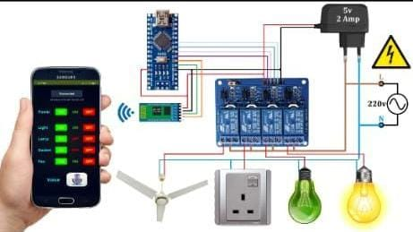

Figure 3.1 Block Diagram of Proposed Method

**4.TOOLS USED**

**HARDWARE REQUIREMENT**

* + - ARDUINO UNO
    - BLUETOOTH HC-05
    - POWER SUPPLY
    - LOAD

**SOFTWARE REQUIREMENT**

* + - Arduino IDE
    - MIT APP INVENTOR

**4.1POWER SUPPLY**

The operation of power supply circuits built using filters, rectifiers and then voltage regulators. Starting with an AC voltage, a steady DC voltage is obtained by rectifying the AC voltage, then filtering to a DC level, and finally regulating to obtain a desired fixed DC voltage.The regulation is usually obtained from an IC voltage regulator unit, which remain the same if the input DC voltage varies or the output load connected to DC voltage changes. A diode rectifier that provides a full-wave rectified voltage that is initially filtered by a simple capacitor filter to produce a DC voltage. A regulated circuit can use this DC inputs to provide a DC voltage that not only has much less ripple voltage but also remains the same DC value even if the input DC voltage varies somewhat or the load connected to the output DC voltage changes this voltage regulation is usually obtained using one of a number of popular voltage regulation IC unit.In this circuit 230v AC is given as input to the primary windings of the transformer, which step-down’s the 230v into 12v Ac supply. Then the 12v Ac supply is converted into the 12v dc supply using bridge rectifier.1000uf capacitor is used to change the pulsating dc into pure dc.5v dc output is taken from the voltage Regulator-7805, which consists of 3 pins. First pin is given input 12v dc and center pin given ground supply, output 5v dc is taken from the third pin.

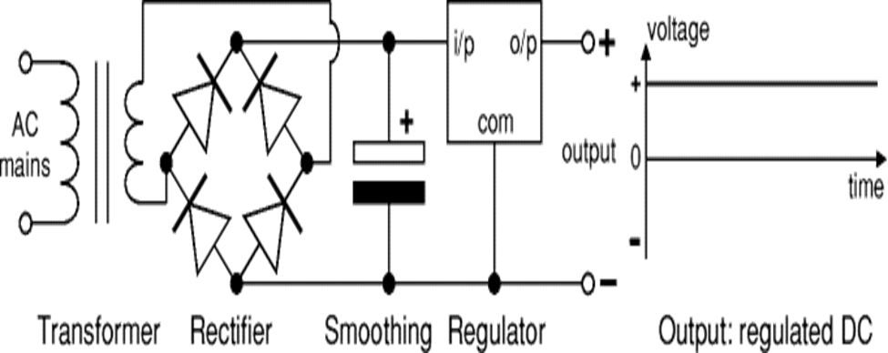

## 

## Figure 4.1 : POWER SUPPLY

**4.2 Arduino UNO**

Arduino is a tool for making computers that can sense and control more of the physical world than your desktop computer. It's an open-source physical computing platform based on a simple microcontroller board, and a development environment for writing software for the board. Arduino can be used to develop interactive objects, taking inputs from a variety of switches or sensors, and controlling a variety of lights, motors, and other physical outputs. Arduino projects can be stand-alone, or they can communicate with software running on your computer (e.g. Flash, Processing.) The boards can be assembled by hand or purchased preassembled; Then the 12v Ac supply is converted into the 12v dc supply using bridge rectifier.1000uf capacitor is used to change the pulsating dc into pure dc.5v dc output is taken from the voltage Regulator-7805, which consists of 3 pins. First pin is given input 12v dc and center pin given ground supply, output 5v dc is taken from the third pin the open source IDE can be downloaded for free. The Arduino Uno is a microcontroller board based on the ATmega328. It has 14 digital input/output pins (of which 6 can be used as PWM outputs), 6 analog inputs, a 16 MHz ceramic resonator, a USB connection, a power jack, an ICSP header, and a reset button. The boards can be assembled by hand or purchased preassembled; the open source IDE can be downloaded for free. It contains everything needed to support the microcontroller; simply connect it to a computer with a USB cable or power it with a AC-to-DC adapter or battery to get started.

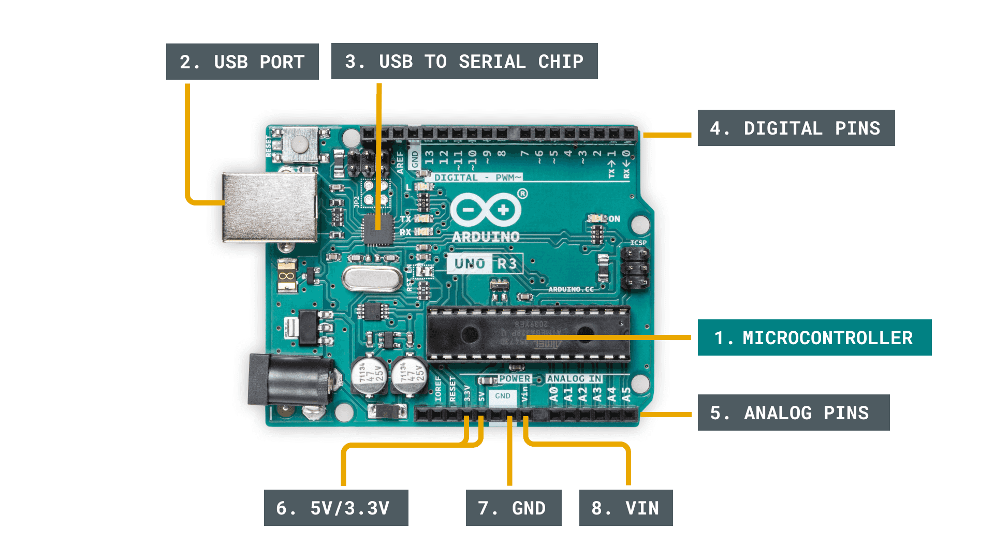

## 

## Figure 4.2 : Arduino Uno

**4.3. BLUETOOTH HC-O5**

The HC-05 is an easy to connect and easy to used Bluetooth module, which is designed for wireless serial connection. The Bluetooth module can be used as master or slave configuration, making it best solution for wireless connection or communication. This module is version 2.Bluetooth communication technology which is great for transferring and receiving data in fast rate.

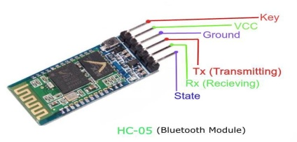

Figure 4.3 : Bluetooth Module

**4.4 RELAY**

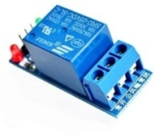A relay is an electro-magnetic switch which is useful to switch a low voltage to switch on and off a light bulb (or anything else) connected to the 220v mains supply. Relay and pump motors operating voltage is 12v dc supply. Relay is nothing but it is the electromagnetic switch. Relay allows one circuit to switch another circuit while they are separated. Relay is used when we want to use a low voltage circuit to turn ON and OFF the device which required high voltage for its operation. For example, 5V supply connected to the relay is sufficient to drive the bulb operated on 230V AC mains. Relays are available in various configurations of operating voltages like 6V, 9V, 12V, 24V and so on. Relay is divided into two parts, one is input and other is output. Input side is nothing but a coil which generate magnetic field when small input voltage is given to it. Relay having three contactors: Normally closed (NC), Normally opened (NO) and common (COM). By using the proper combinations of the contactors electrical appliances may turn ON or OFF. The red colour wire denotes the + VE supply, black colour wire denotes the –VE supply in the diagram. so a transistor is usually needed. In our project we use relay driver to switch the pumps and motors. So to switch the lamp, fan and water heater using that low voltage dc, relay driver is used.

Figure 4.4 : Relay

**5. SOFTWARE REQUIRMENT**

**5.1 Arduino IDE**

Arduino IDE is an application that is used to write codes and uploads them to the Node MCU board. In this project, Arduino IDE is used for coding, debugging, and testing the functionalities of the IOT smart Home Automation system and its components. Arduino IDE has other features, such as a debugging area in case of abnormal conditions to support various Arduino boards, additional libraries, and a serial monitor for communicating with the board. Arduino libraries are usually expressed as dot CPP files based on software abstraction called wiring. Wiring allows the easy control of hardware ports through simple functions without consulting data sheets and being delayed in pin mapping. Arduino uses the bits of C and C++, but the general flow and structure of the code are heavily based around C.

**5.2 MIT APP INVENTOR**

MIT App Inventor is an intuitive, visual programming environment that allows everyone even children to build fully functional apps for smart phones and tablets. App Inventor is a free, cloud-based service that allows you to make your own mobile apps using a blocks-based programming language. MIT App Inventor is a web application integrated development environment originally provided by Google, and now maintained by the Massachusetts Institute of Technology (MIT). It allows newcomers computer programming to create application software (apps) for two operating systems (OS): Android , and ios , which, as of 8 July 2019, is in final beta testing. It is free and open-source software released under dual license: a , and an Apache License 2.0  for the source code.

It uses a graphical user interface (GUI) very similar to the programming languages Scratch  (programming language) and the Star Logo, which allows users to drag and drop visual objects to create an application that can run on Android devices, while an App-Inventor Companion (the program that allows the app to run and debug on) that works on iOS running devices are still under development. In creating App Inventor,

**6. WORKING PROCEDURE**

Human- machine interaction (HMI) has become, the more realistic in day-to-day life due to the advancement in the technology. Aim of this application is to connect any things through the Bluetooth that can be accessible from Home.

START

OPEN THE APP

CLICK ON BUTTON/ SPEECH THE COMMAND

SEND DATA THROUGH BLUETOOTH

DATA RECEIVED BY THE ARDUINO

DATE SEND TO THE RELAY BOARD

RELAY BOARD PASS DATA = ON/OFF

ON/OFF THE APPLIANCE

STOP

CONNECT MOBILE WITH BLUETOOTH

**Table. 6.1 Working Procedure**

**7. RESULT AND DISCUSSION**

The system as the name indicates, ‘Home automation’ makes the system more flexible and provides attractive user interface compared to other home automation systems. In this system we integrate mobile devices into home automation systems. A novel architecture for a home automation system is proposed using the relatively new communication technologies. The system consists of mainly three components is a BLUETOOTH module, Arduino microcontroller and relay circuits. WIFI is used as the communication channel between android phone and the Arduino microcontroller. We hide the complexity of the notions involved in the home automation system by including them into a simple, but comprehensive set of related concepts. This simplification is needed to fit as much of the functionality on the limited space offered by a mobile device’s display. This paper proposes a low cost, secure, ubiquitously accessible, auto-configurable, remotely controlled solution. The approach discussed in the paper is novel and has achieved the target to control home appliances remotely using the WiFi technology to connects system parts, satisfying user needs and requirements. WiFi technology capable solution has proved to be controlled remotely, provide home security and is cost effective as compared to the previously existing systems. Hence we can conclude that the required goals and objectives of home automation system have been achieved. The system design and architecture were discussed, and prototype presents the basic level of home appliance control and remote monitoring has been implemented. Finally, the proposed system is better from the scalability and flexibility point of view than the commercially available home automation systems

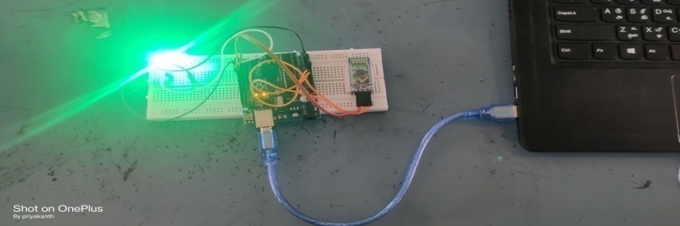

Figure 7.1 : Result

**8. CONCLUSION**

The system as the name indicates, ‘Home automation’ makes the system more flexible and provides attractive user interface compared to other home automation systems. In this system we integrate mobile devices into home automation systems. A novel architecture for a home automation system is proposed using the relatively new communication technologies. The system consists of mainly three components is a BLUETOOTH module, Arduino microcontroller and relay circuits. WIFI is used as the communication channel between android phone and the Arduino microcontroller. We hide the complexity of the notions involved in the home automation system by including them into a simple, but comprehensive set of related concepts. This simplification is needed to fit as much of the functionality on the limited space offered by a mobile device’s display. This paper proposes a low cost, secure, ubiquitously accessible, auto-configurable, remotely controlled solution. The approach discussed in the paper is novel and has achieved the target to control home appliances remotely using the Wi-Fi technology to connects system parts, satisfying user needs and requirements. Wi-Fi technology capable solution has proved to be controlled remotely, provide home security and is cost effective as compared to the previously existing systems. Hence we can conclude that the required goals and objectives of home automation system have been achieved. The system design and architecture were discussed, and prototype presents the basic level of home appliance control and remote monitoring has been implemented. Finally, the proposed system is better from the scalability and flexibility point of view than the commercially available home automation systems Hence we can conclude that the required goals and objectives of home automation system have been achieved. The system design and architecture were discussed, and prototype presents the basic level of home appliance control and remote monitoring has been implemented. Finally, the proposed system is better from the scalability and flexibility point of view than the commercially available home automation systems

**REFERENCE**

1. A. Paul, M. Panja, M. Bagchi, N. Das, R. M. Mazumder, and S. Ghosh, “Voice recognition based wireless room automation system,” in 2016 International Conference on Intelligent Control, Power and Instrumentation, ICICPI 2016, 2017.
2. A. Bekkelien, “Bluetooth indoor positioning,” Master’s thesis, Univ. Geneva, 2012.
3. T. S. Ng, “Microcontroller,” in Studies in Systems, Decision and Control, 2016.
4. E. L. Horsley, M. P. Foster, and D. A. Stone, “State-of-the-art piezoelectric transformer technology,” in 2007 European Conference on Power Electronics and Applications, EPE, 2007.
5. D. R. Tobergte and S. Curtis, “Arduino Uno,” J. Chem. Inf. Model., 2013.
6. A. Cotta, N. T. Devidas, and V. K. N. Ekoskar, “HC-05 BLUETOOTH MODULE INTERFACED WITH ARDUINO,” Int. J. Sci. Eng. Technol. Res., 2016.
7. M. Spencer et al., “Demonstration of integrated micro-electro- mechanical relay circuits for VLSI applications,” in IEEE Journal of Solid-State Circuits, 2011.
8. Home Automation. From <https://en.wikipedia.org/wiki/Home_automation>

<https://internetofthingsagenda.techtarget.com/definition/>